UNITED STATES
SECURITIES AND EXCHANGE COMMISSION
Washington, D.C. 20549
SCHEDULE 14A
Proxy Statement Pursuant to Section 14(a) of the Securities
Exchange Act of 1934 (Amendment No. )
Filed by the Registrant ☒
Filed by a Party other than the Registrant ☐
Check the appropriate box:
☐ Preliminary Proxy Statement
☐ Confidential, for Use of the Commission Only (as permitted by Rule 14a-6(e)(2))
☐ Definitive Proxy Statement
☒ Definitive Additional Materials
☐ Soliciting Material Pursuant to §240.14a-12
SCHOLASTIC CORPORATION
(Name of Registrant as Specified In Its Charter)
(Name of Person(s) Filing Proxy Statement, if other than the Registrant)
Payment of Filing Fee (Check all boxes that apply):
☒ No fee required
☐ Fee paid previously with preliminary materials
☐ Fee computed on table in exhibit required by Item 25(b) per Exchange Act Rules 14a-6(i)(1) and 0-11

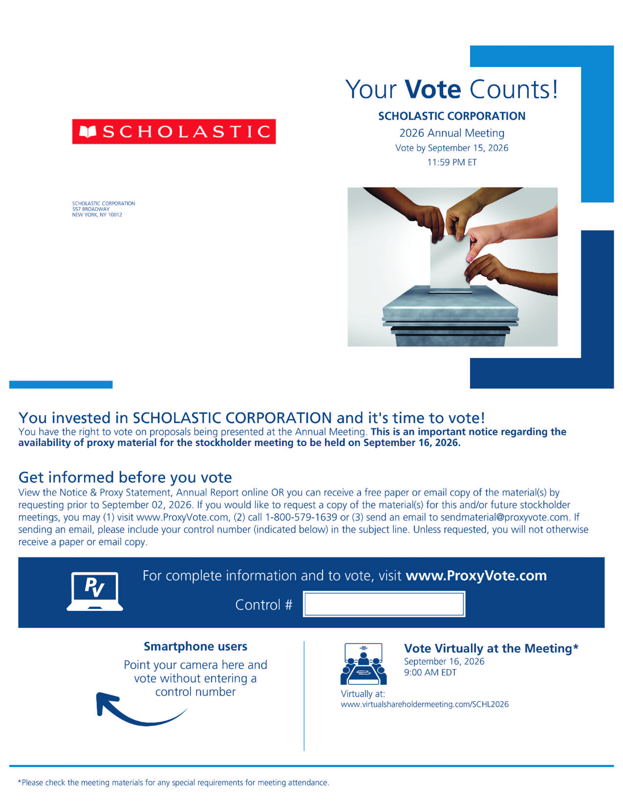

SCHOLASTIC Your Vote Counts! SCHOLASTIC CORPORATION 2026 Annual Meeting Vote by September 15, 2026 11:59 PM ET SCHOLASTIC CORPORATION 557 BROADWAY NEW YORK, NY 10012 You invested in SCHOLASTIC CORPORATION and it's time to vote! You have the right to vote on proposals being presented at the Annual Meeting. This is an important notice regarding the availability of proxy material for the stockholder meeting to be held on September 16, 2026. Get informed before you vote View the Notice & Proxy Statement, Annual Report online OR you can receive a free paper or email copy of the material(s) by requesting prior to September 02, 2026. If you would like to request a copy of the material(s) for this and/or future stockholder meetings, you may (1) visit www.ProxyVote.com, (2) call 1-800-579-1639 or (3) send an email to sendmaterial@proxyvote.com.If sending an email, please include your control number (indicated below) in the subject line. Unless requested, you will not otherwise receive a paper or email copy. For complete information and to vote, visit www.ProxyVote.com Control # Smartphone users Point your camera here and vote without entering a number Vote Virtually at the Meeting* September 16, 2026 9:00 AM EDT Virtually at: www.virtualshareholdermeeting.com/SCHL2026*Please check the meeting materials for any special requirements for meeting attendance.

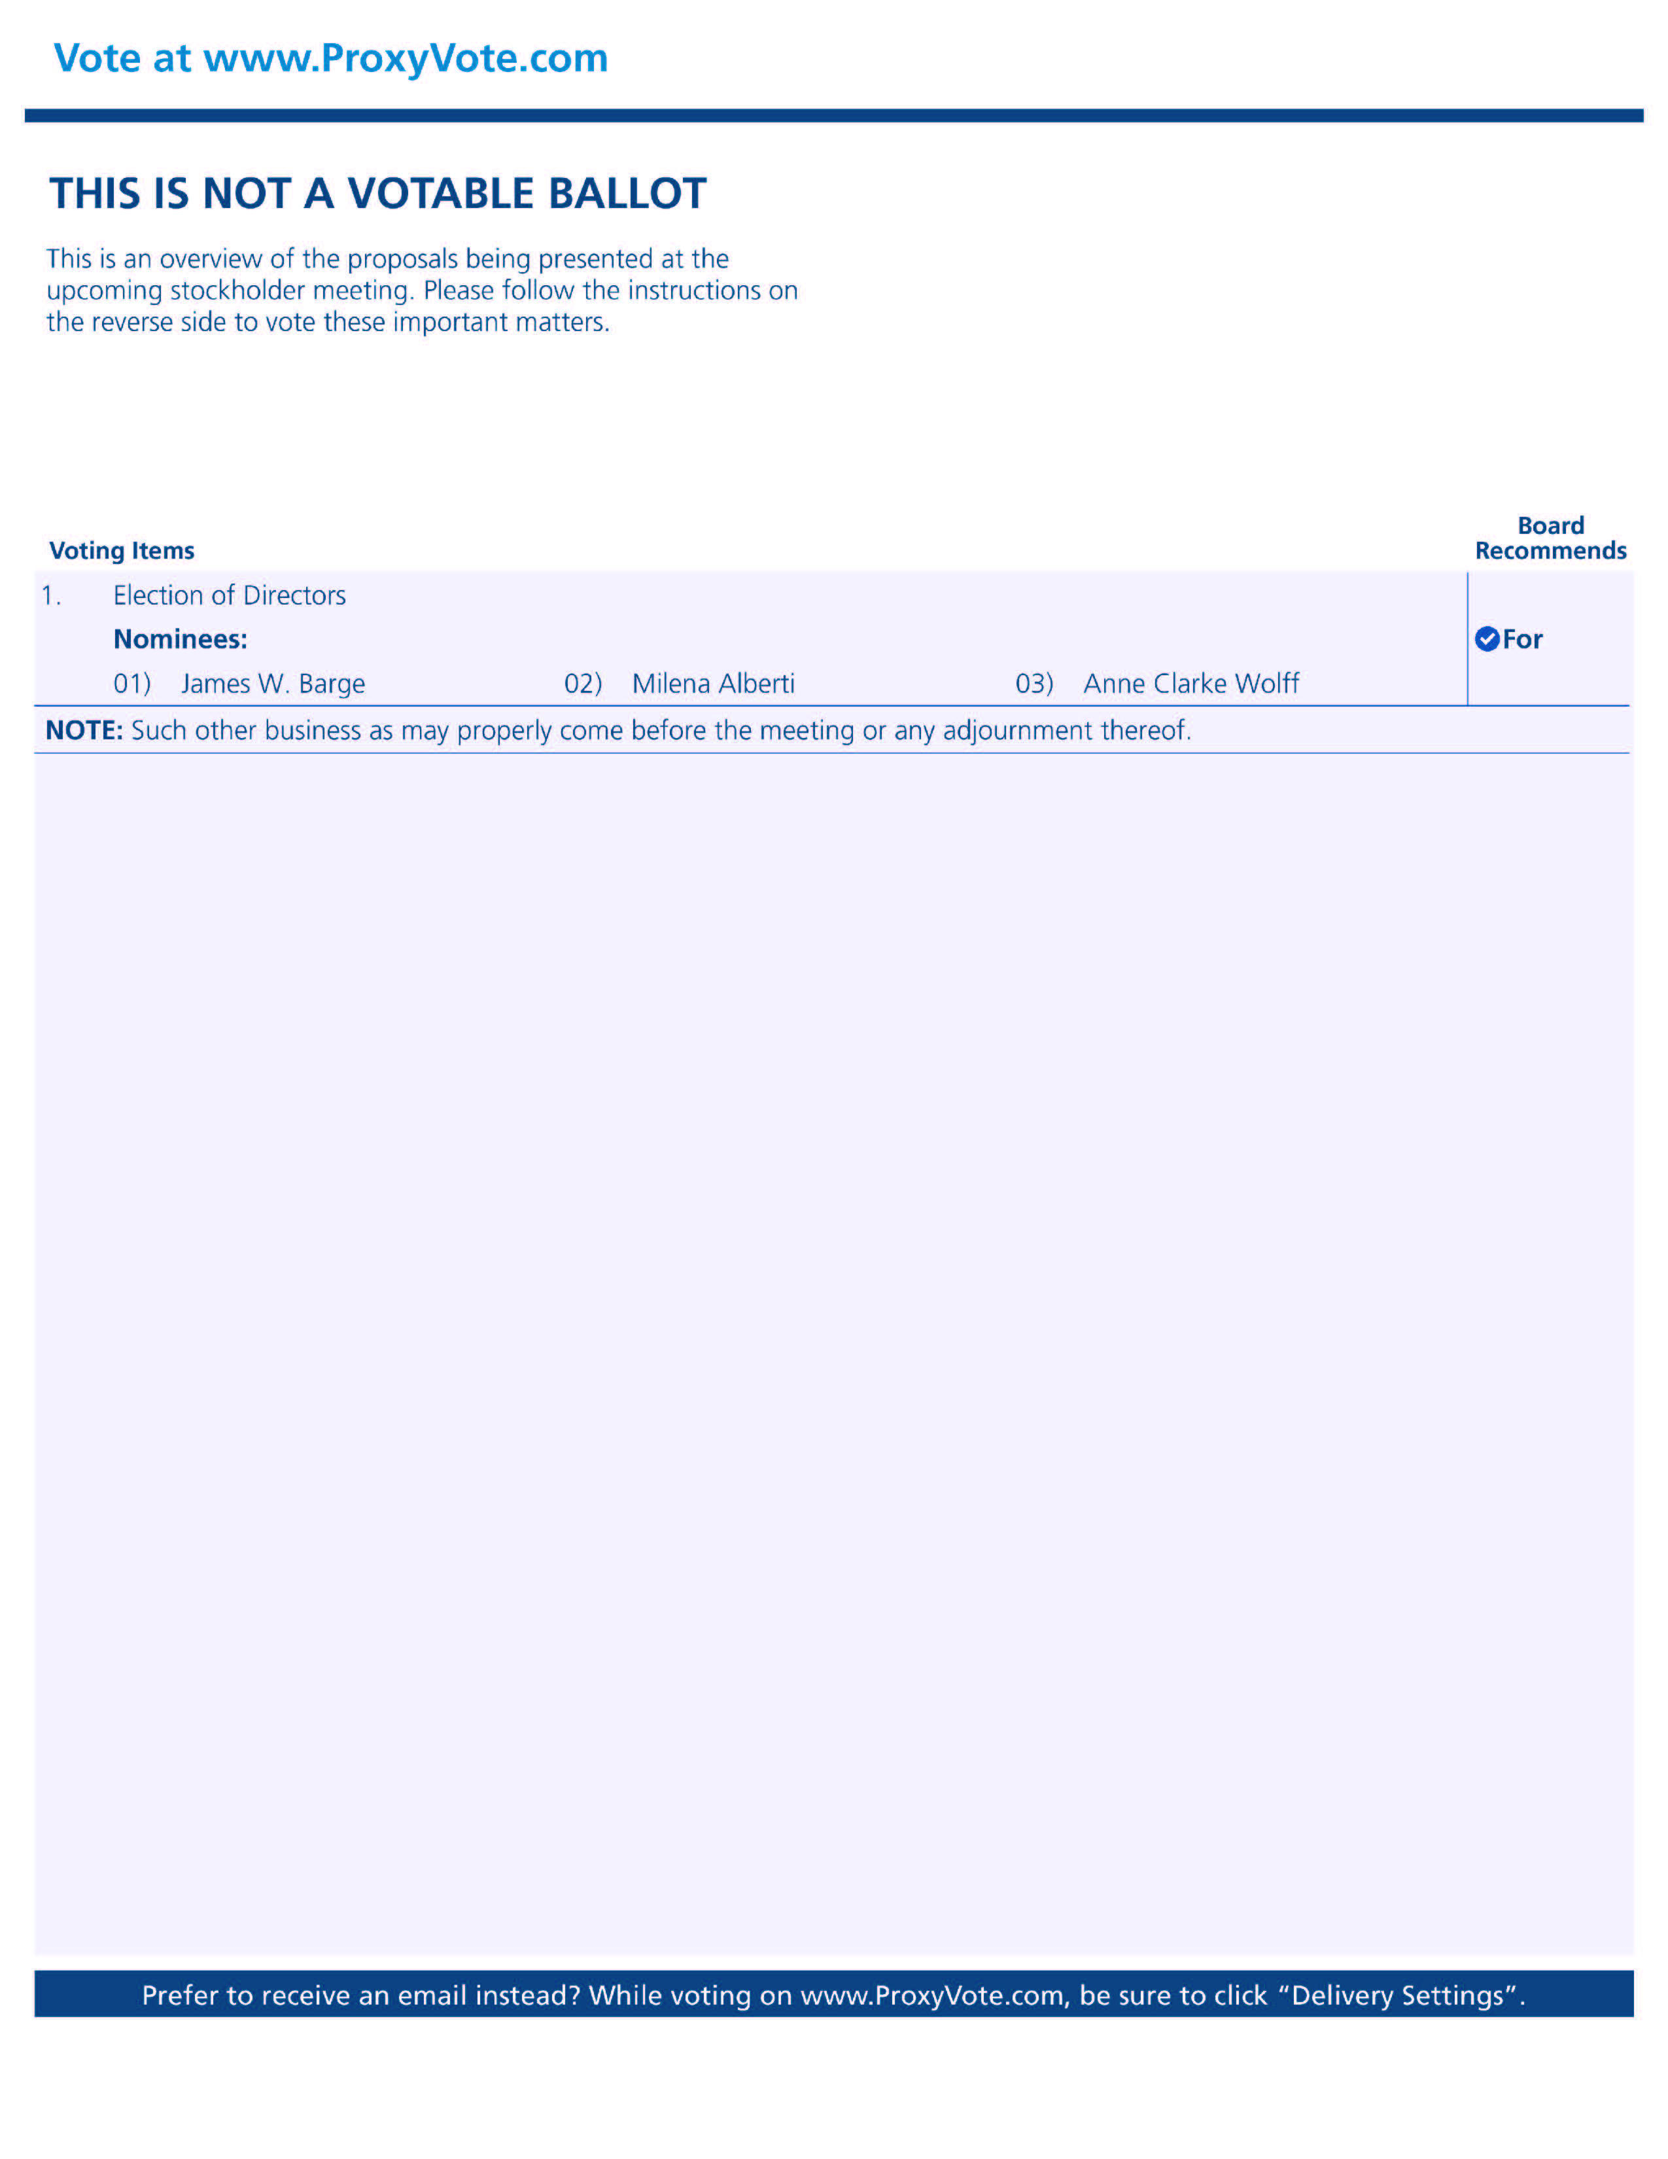

Vote at www.ProxyVote.comTHIS IS NOT A VOTABLE BALLOT This is an overview of the proposals being presented at the upcoming stockholder meeting. Please follow the instructions on the reverse side to vote these important matters. Voting Items Election of Directors Nominees: 01) James 02) Milena Alberti 03) Anne Clarke Wolff Board Recommends NOTE: Such other business as may properly come before the meeting or any adjournment thereof Prefer to receive an email instead? While voting on www.ProxyVote.com, be sure to click "Delivery Settings".

